South Church Preschool
September 2020

It is that time of year again and our teachers are so very excited to begin the new school year with their students. We have exciting curriculum and fun events planned for our coming months. Happily, our center has grown through the years and we have many students who can share in the fun and learning here at SCPS.

Unfortunately, the pandemic is still out there and we have had to put a lot of new protocol in place due to COVID. One being that our classes are much smaller and we have split them into morning and afternoon sessions.

As always, parents and families can help us by reading all the important hand-outs and being prepared with all the paperwork that we need to collect. In addition, following the school rules and protocol is so important, especially when it comes to drop-off and pick-up instructions.
Our staff is always glad to answer any questions parents, grandparents, or caregivers may have about school protocol. We really need all of your cooperation, diligence and patience to make this school year work.

Please read the attached protocol thoroughly, as it will guide you through the first weeks of school, which are now so different than in previous years.

We know that our little ones are excited and probably a little anxious about starting or returning to school. We are hoping to make sure that ALL of our students transition into their classrooms happily and comfortably. We are doing our very best to set up activities and put together strategies that will ease the nerves and lure our students into our nurturing learning environment. Our classrooms will be inviting and our teachers will be kind, caring and patient. There will be so many activities set up in our classrooms each day to help ease their fears.
Collectively, teaching teams and parents can make their child’s school experience successful.

Though we will have limited parent visits and our drop off is now at the school entrances, our staff will be sending lots of pictures home to you each week, so you can have peace of mind that the kids are acclimating well. We are working together to plan events that can incorporate our families into some of the fun in a safe way.

Parents can help us by doing the following…

Putting consistent bedtime strategies in place early in the school year.
In the beginning of the school season, children may have some restless nights, so starting bedtime a little earlier can sometimes be helpful when it comes to getting enough sleep.

Breakfast is truly one of the most important meals for children and gives them the energy they need to begin their day.

Giving yourself and your children a little extra time in the morning before leaving for school, helps make a happier drop-off.

Being on time for drop-off and pick-up develops trust in both parent relationships and teacher relationships with children. Arriving with other classmates helps with separation anxiety.

Have backpacks and lunch boxes ready in the morning so when it is time to leave, it is just pick-up and go! This will avoid stall tactics on the part of your children when it comes to leaving for school.
Being on time for drop-off and pick-up develops trust in both parent relationships and teachers’ relationships with your children.
Arriving and leaving with their classmates helps with separation anxiety.

During these crazy times, it is so important that parents remain calm and give the children a feeling of safety somehow, even though things in the world are a little scary right now. School should be a safe place for children to enjoy learning. Please know that we will be doing our very best to provide that. We have plans in place for just about anything that can arise. We will be in constant communication with you through-out the weeks and months.

It is IMPORTANT that parents read all the protocol information,
hand-outs, newsletters, emails and resources that get sent from
school.

What to Bring to School?

*** Students should have the following in their backpacks:

- Extra pair of clothes and/or pull-up (NO DIAPERS PLEASE).
- Lunch box that fits inside their backpacks, for those students who stay until 1:00.
- Proper shoes for playground and gym class – season appropriate
- A picture of their family or a “Lovey” from home is perfectly acceptable if it will help the child adjust to being away from family while at school.
- Water Bottle (optional).

What Not to bring to School

Students should not bring the following items to school in their backpacks.

- Creams or lotions of any kind.
- Any kind of medication
- Inhalers (must have a doctor’s note and be kept in our first aide cabinet).
- Toys that they will have trouble sharing with their class.
- Toy guns or any kind of toy weapons.
- Electronic equipment
- Food other than their lunch or snack

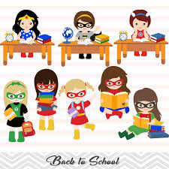
CURRICULUM

This month we begin our school year with our super hero theme.
We will be talking about the following:

What is a real super hero?

- Helpers in our community
- Being brave
- Meeting new friends
- Keeping ourselves and others safe

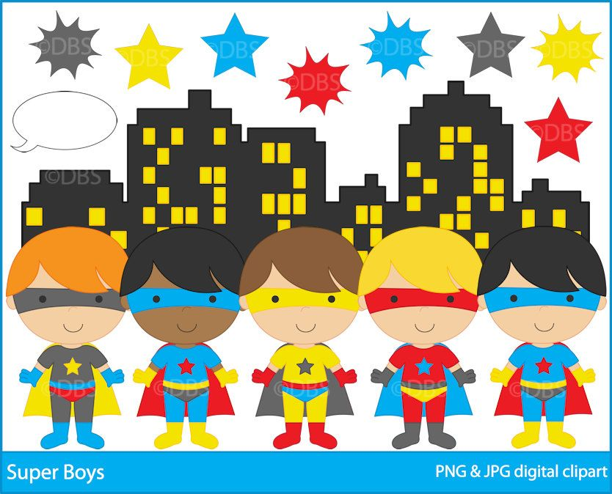
Gym Classes

This year our teachers will conduct gym class each week with the children. They will use this time to:

- Observe large motor skills
- Foster teamwork
- Work on Gross motor muscle development
Let some energy out with the students

- Have Fun

Usually we have Mrs. Wegner teach gym to all of our students, but due to COVID protocol, classroom teachers, along with Mrs. Letizia,
Will take their own individual classes to the gym room for exercise.

They will also be doing exercise outside on our playground with a lot of outdoor fun and group games.

Each class will have a gym class every week with their teachers and their classmates.

Inclement Weather Policy

If Glastonbury schools are delayed for weather issues, SCPS will open at 11:00, and snack will not be served on that day since it is close to lunch time for the students.

In the case of morning delays, our 5-day Pre-K class will come in 11 to 1:00.
All other morning classes will be cancelled. Our PM classes will still have school
12:30 to 3:00.

In the case of early dismissal, all morning classes will dismiss at 11:30 and all afternoon classes will be cancelled

* Parents will have to check the school hot line or television to check on delays and early dismissals. Teachers will not be calling families to advise them of these changes. SCHOOL HOT LINE NUMBER: 860-652-7953

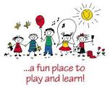

MUSIC CLASSES WILL BEGIN IN OCTOBER

Starting in October Ms. Kathye will be visiting each month for music class. Each class will have music with their individual classmates only. Ms. Kathye will be masked and socially distanced from our students. As you know, music is a huge part of our program and we really wanted to continue this in the safest way we can. We ae lucky to have a large space for this. All instruments will be washed and cleaned between classes.
_____________________________________________________________

Tuition
All first quarter tuition payments should be sent in by this time in the school year in preparation for your child’s first day of school. If you have any questions regarding these payments, please call any of the following numbers. Your next quarterly payment is due November 1st. Please be prompt with these payments. They can be mailed or placed in our mailbox which will now be placed in the school by our front entrance.

Business Office. Lynn David. 860-416-7726
Registration Administrator. Heidi Gourley 860-430-6734
Director Stephanie Letizia 860-836-4174

