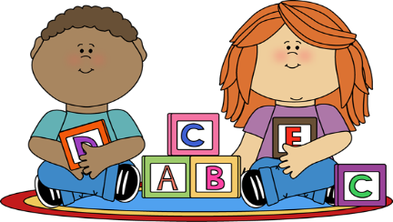
South Church Preschool’s Discipline Policy

Our discipline policy here at South Church Preschool is derived from our belief that good discipline is education and guidance. Our goal is to build leadership and self-confidence in our students with the idea that our students feel secure that they are in a safe and fair environment.

The strategies we use in our classrooms are as follows:
- The use of positive guidance
- Redirection
- Setting clear limits
- Continuous supervision by staff throughout the day and especially when the students are interacting independently at school.
- Specifically prohibiting abusive, neglectful, corporal, humiliating or frightening punishment.
- Managing a child’s behavior using techniques based on developmentally appropriate practice.

Please sign stating that you have reviewed,verbally discussed with a teacher and understand our policies.

Student Name:______________________________________________

Parent Signature:____________________________________________

September 2023

Parent Copy

South Church Preschool’s Discipline Policy

Our discipline policy here at South Church Preschool is derived from our belief that good discipline is education and guidance. Our goal is to build leadership and self-confidence in our students with the idea that our students feel secure that they are in a safe and fair environment.

The strategies we use in our classrooms are as follows:
- The use of positive guidance
- Redirection
- Setting clear limits
- Continuous supervision by staff throughout the day and especially when the students are interacting independently at school.
- Specifically prohibiting abusive, neglectful, corporal, humiliating or frightening punishment.
- Managing a child’s behavior using techniques based on developmentally appropriate practice.

Please keep this copy for your personal records.
September 2023

